The Nautilus DevOps team is focusing on improving their data security by using AWS KMS. Your task is to create a KMS key and manage the encryption and decryption of a pre-existing sensitive file using the KMS key.
Specific Requirements:
- Create a symmetric KMS key named devops-KMS-Key to manage encryption and decryption.
- Encrypt the provided SensitiveData.txt file (located in /root/), base64 encode the ciphertext, and save the encrypted version as EncryptedData.bin in the /root/ directory.
- Try to decrypt the same and verify that the decrypted data matches the original file.
Make sure that the KMS key is correctly configured. The validation script will test your configuration by decrypting the EncryptedData.bin file using the KMS key you created.

Use below given AWS Credentials: (You can run the showcreds command on aws-client host to retrieve these credentials)
Console URL | https://881517795257.signin.aws.amazon.com/console?region=us-east-1
Username | kk_labs_user_573715
Password | n8qTbNL8l5Nz
Start Time | Tue Jan 13 08:15:28 UTC 2026
End Time | Tue Jan 13 09:15:28 UTC 2026
Notes:
- Create the resources only in us-east-1 region.
- To display or hide the terminal of the AWS client machine, you can use the expand toggle button as shown below:
Solutions:-
~ on ☁️ (us-east-1) ➜ ls
SensitiveData.txt
Create the KMS Key
create a symmetric KMS key named devops-KMS-Key in us-east-1.
🔐 Step 1: Create the KMS Key in Console
- Sign in to AWS Console Use the provided console URL: 👉 AWS Console (us-east-1) Log in with your username and password.
- Navigate to KMS
  - In the AWS Console search bar, type KMS or Key Management Service.
  - Select Key Management Service.
- Create a Key
  - Click Create key.
  - Choose Symmetric (since we want ENCRYPT/DECRYPT).
  - Select Key usage: Encrypt and decrypt.
  - Click Next.
- Configure Key Details
  - Enter Alias: alias/devops-KMS-Key.
  - Description: Symmetric key for DevOps encryption.
  - Region: Ensure it’s us-east-1.
- Define Key Administrators
  - Add your IAM user (kk_labs_user_573715) as the administrator.
  - This allows you to manage the key.
- Define Key Usage Permissions
  - Add the same IAM user (kk_labs_user_573715) under Key users.
  - This allows you to use the key for encryption/decryption.
- Review and Create
  - Review the settings.
  - Click Finish to create the key.
- Encrypt the Sensitive File
- Your file is located at /root/SensitiveData.txt. Use the KMS key to encrypt it:
aws kms encrypt \
--key-id alias/devops-KMS-Key \
--plaintext fileb:///root/SensitiveData.txt \
--output text \
--query CiphertextBlob \
--region us-east-1 | base64 --decode > /root/EncryptedData.bin

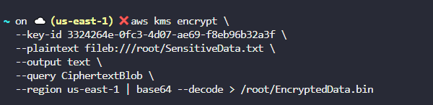

Decrypt and Verify
Now decrypt the file to confirm it matches the original:

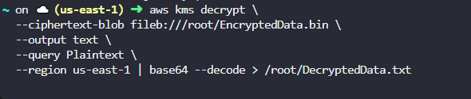

Finally, compare the decrypted file with the original:
diff /root/SensitiveData.txt /root/DecryptedData.txt

